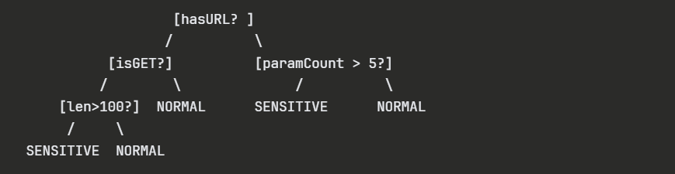

RandomForestClassifier(
n_estimators=10, # 10 trees inside each weak model
max_depth=3, # each tree can only go 3 levels deep
min_samples_leaf=10,
max_features='sqrt',
random_state=10 + i
)
```

So each weak model is itself **10 small trees**.

---

**STEP 1: How one single Decision Tree gives a probability**

Imagine a single tree with max_depth=3:
```
[hasURL? ]
/ \
[isGET?] [paramCount > 5?]
/ \ / \
[len>100?] NORMAL SENSITIVE NORMAL
/ \
SENSITIVE NORMAL
```

A request comes in and travels down the tree following the rules at each node until it hits a **leaf node**.

That leaf node contains all training samples that ended up there. For example:
```
Leaf node contains:
- 8 sensitive requests
- 2 normal requests
Total = 10

Probability = 8/10 = 0.80
```

So the tree says **"I think this request is 80% likely to be sensitive"**

---

**STEP 2: How Random Forest combines 10 trees into one probability**

Your weak model has `n_estimators=10` meaning 10 trees. Each tree gives its own probability:
```
Request #42 goes through all 10 trees:

Tree 1 → leaf has 8 sensitive / 2 normal → prob = 0.80
Tree 2 → leaf has 7 sensitive / 3 normal → prob = 0.70
Tree 3 → leaf has 2 sensitive / 8 normal → prob = 0.20
Tree 4 → leaf has 9 sensitive / 1 normal → prob = 0.90
Tree 5 → leaf has 3 sensitive / 7 normal → prob = 0.30
Tree 6 → leaf has 8 sensitive / 2 normal → prob = 0.80
Tree 7 → leaf has 1 sensitive / 9 normal → prob = 0.10
Tree 8 → leaf has 7 sensitive / 3 normal → prob = 0.70
Tree 9 → leaf has 2 sensitive / 8 normal → prob = 0.20
Tree 10 → leaf has 8 sensitive / 2 normal → prob = 0.80

Average = (0.80+0.70+0.20+0.90+0.30+0.80+0.10+0.70+0.20+0.80) / 10
= 0.55
```

So weak model 1 says **probability = 0.55** for request #42.

---

**STEP 3: Why are the 10 trees different from each other?**

Two reasons:

**Reason 1 — Random feature selection (`max_features='sqrt'`)**
```
You have say 20 features total.
sqrt(20) = ~4 features

Tree 1 randomly picks: [hasURL, isGET, paramCount, headerLen]
Tree 2 randomly picks: [isPOST, pathLen, hasAuth, queryLen]
Tree 3 randomly picks: [hasURL, isPOST, pathLen, paramCount]
```
Each tree only sees a random subset of features at each split so they learn different patterns.

**Reason 2 — Bootstrap sampling**
Each tree is trained on a random sample of the training data with replacement:
```
Tree 1 trains on: rows [1,1,5,3,8,2,8,9,4,...] ← some rows repeated, some missing
Tree 2 trains on: rows [2,4,4,7,1,9,3,6,1,...] ← different random sample
Tree 3 trains on: rows [5,5,2,8,3,1,7,4,9,...] ← different again

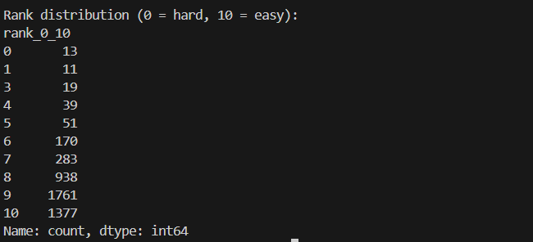

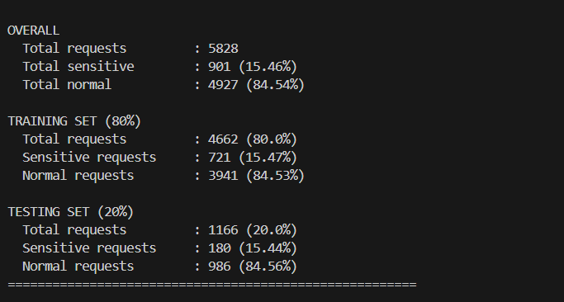

Without disagreement

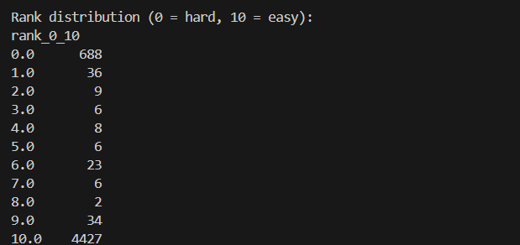

Result with balanced class
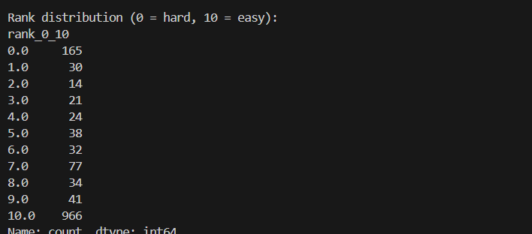

With smote :

import numpy as np
import pandas as pd
from sklearn.model_selection import train_test_split
from sklearn.ensemble import RandomForestClassifier
from sklearn.metrics import f1_score, roc_auc_score
from imblearn.over_sampling import SMOTE

# ============================================================
# STEP 1: LOAD DATA
# ============================================================

df = pd.read_csv("dataset/features_matrix.csv")

df = df[(df['isGET'] == 1) | (df['isPOST'] == 1)]
df = df[df['flag'].isin(['y', 'n'])]

discard_cols = [
'reqId', 'flag',
'changeInParams',
'passwordInPath',
'payInPath',
'viewInParams'
]

X = df.drop(columns=discard_cols, errors='ignore')
y = df['flag'].map({'y': 1, 'n': 0})

print("Dataset size:", len(X))
print("Sensitive ratio:", y.mean())

# ============================================================
# STEP 2: SPLIT FIRST
# ============================================================

X_train, X_test, y_train, y_test = train_test_split(
X, y,
test_size=0.1,
stratify=y,
random_state=42
)

X_train = X_train.reset_index(drop=True)
y_train = y_train.reset_index(drop=True)

X_test = X_test.reset_index(drop=True)
y_test = y_test.reset_index(drop=True)

print("\nTrain size (before SMOTE):", len(X_train))
print("Test size :", len(X_test))
print("Sensitive ratio (before SMOTE):", y_train.mean())

# ============================================================
# STEP 2.5: APPLY SMOTE ON TRAIN ONLY
# ============================================================

smote = SMOTE(random_state=42)
X_train, y_train = smote.fit_resample(X_train, y_train)

X_train = pd.DataFrame(X_train, columns=X.columns)
y_train = pd.Series(y_train)

N_train = len(X_train)

print("\nTrain size (after SMOTE) :", N_train)
print("Sensitive ratio (after SMOTE):", y_train.mean())

# ============================================================
# STEP 3: TRAIN WEAK MODELS (FULL TRAIN)
# ============================================================

NUM_WEAK_MODELS = 10

correctness_matrix = np.zeros((N_train, NUM_WEAK_MODELS))
weak_auc_scores = []

print("\nTraining weak models...")

for i in range(NUM_WEAK_MODELS):

clf = RandomForestClassifier(
n_estimators=10,
max_depth=3,
min_samples_leaf=10,
max_features='sqrt',
random_state=10 + i,
n_jobs=-1
)

clf.fit(X_train, y_train)

probs = clf.predict_proba(X_train)[:, 1]
preds = (probs >= 0.5).astype(int)

correctness_matrix[:, i] = (preds == y_train).astype(int)

auc_i = roc_auc_score(y_train, probs)
weak_auc_scores.append(auc_i)

print(f"Weak Model {i+1} Train AUC = {auc_i:.4f}")

print("\nMean Weak AUC (Train) = {:.4f}".format(np.mean(weak_auc_scores)))

# ============================================================
# STEP 4: HARDNESS BASED ON CORRECTNESS
# 0 = HARDEST
# 10 = EASIEST
# ============================================================

correct_count = correctness_matrix.sum(axis=1)

rank_0_10 = correct_count

ranking_df = pd.DataFrame({
"row_id": np.arange(N_train),
"true_label": y_train,
"rank_0_10": rank_0_10
})

print("\nRank distribution (0 = hard, 10 = easy):")
print(ranking_df["rank_0_10"].value_counts().sort_index())

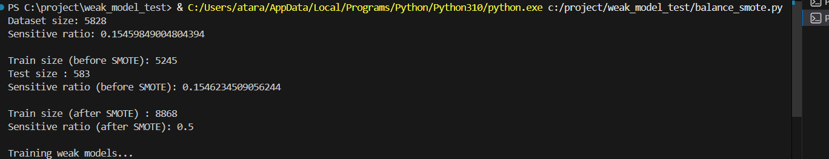
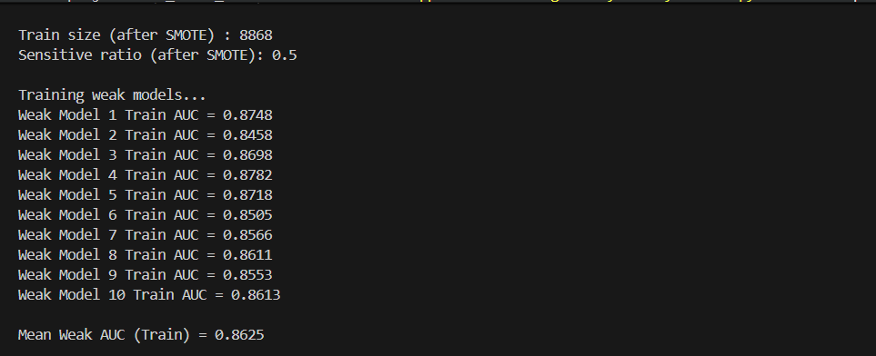
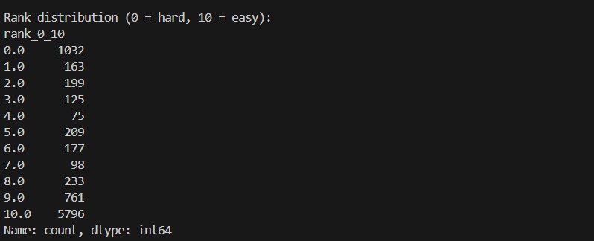

Compare side by side

